

NAME: AJAY KUMAR REDDY
REG NO:192425274
COURSE CODE: MLA0214
COURSE NAME: FUNDAMENTAL OF MACHINE LEARNING

QUESTION: Build an Artificial Neural Network by implementing the Backpropagation algorithm and test the same using appropriate data sets.
AIM:
To implement an Artificial Neural Network using Backpropagation algorithm.
ALGORITHM:
- Start the program.
- Define input and output data.
- Create a neural network model.
- Train the model using the dataset.
- Test the model with a new input.
- Display the prediction.

CODE:
from sklearn.neural_network import MLPClassifier
X = [[0,0],[0,1],[1,0],[1,1]]
y = [0,1,1,0]

model = MLPClassifier(hidden_layer_sizes=(2,),max_iter=1000)
model.fit(X,y)
print("Prediction for [1,0]:",model.predict([[1,0]]))
OUTPUT:
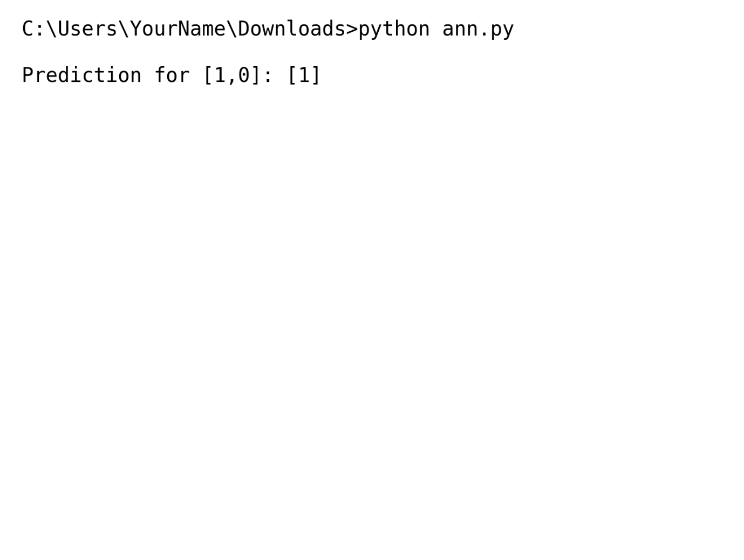
RESULT: The neural network successfully learns from the dataset and predicts outputs using backpropagation.

